**LAB ASSIGNMENT – 1**

**NAME : PRATHAPANI SATWIKA**

**REG.NO. : 20BCD7160**

**Q1. Calculate income tax for the given income by adhering to the below rules:**

**Taxable Income Rate (%) First 5,00,000 0 Second 7,50,000 10 Third 10,00,000 20 Remaining 30**

**Sample Input and output:**

**Enter user's salary:2500000**

**First 5,00,000 Tax: 0**

**CODE :**

income=int(input())

tax_payable = 0

if income <= 500000:

tax_payable = 0

elif (income > 500000 and income <= 750000):

tax_payable = (income - 500000) * 0.10

elif (income > 750000 and income <= 100000):

tax_payable = tax_payable + (income - 750000) * 0.20

else:

tax_payable = tax_payable + (income - 2500000) * 0.20

tax_payable += tax_payable + (income - 1000000)*0.30

print(tax_payable)

**OUTPUT :**

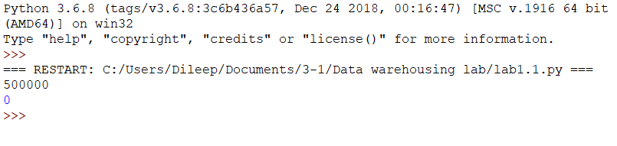**Q2.Write a code to extract each digit from an integer, in the reverse order**

**CODE :**

num = int(input())

reverse = 0

while(num>0):

a=num%10

reverse=reverse*10+a

num = num//10

print(reverse)

**OUTPUT :**

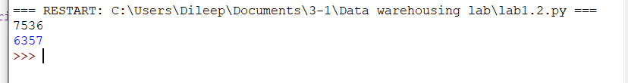

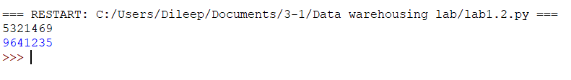

**Q3.Given a list iterate it and display numbers which are divisible by 5 and if you find number greater than 150 stop the loop iteration list1 = [12, 15, 32, 42, 55, 75, 122, 132, 150, 180, 200]**

**Enter the number of elements in the list:11 enter the 0th element**

**12**

**enter the 1th element 15**

**enter the 2th element**

**32**

**enter the 3th element 42**

**enter the 4th element 55**

**enter the 5th element**

**75**

**enter the 6th element 122**

**enter the 7th element 132**

**enter the 8th element 150**

**enter the 9th element**

**180**

**enter the 10th element 200**

**The elements are:**

**15 55 75 150**

**CODE :**

list1 = [12, 15, 32, 42, 55, 75, 122, 132, 150, 180, 200]

for i in list1:

if(i > 150):

break;

if i%5==0:

print(i)

**OUTPUT :**

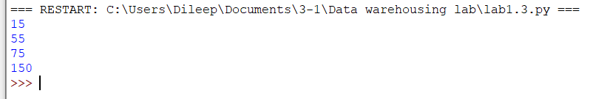

**Q4.** **Create a function showEmployee() in such a way that it should accept employee name, and it’s salary and display both, and**

**if the salary is missing in function call it should show it as 9000**

**Expected Output: showEmployee("Ben", 9000) show Employee("Ben")**

**Should Produce:**

**Employee Ben salary is: 9000 Employee Ben salary is: 9000**

**CODE :**

def show_employee(name, salary=9000):

print("Name:", name, "salary:", salary)

show_employee("Ben", 9000)

show_employee("Ben")

**OUTPUT :**

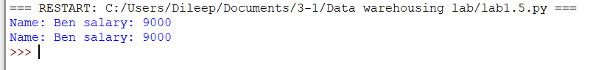

**Q5.Count all lower case, upper case, digits, and special symbols from a given string Given: str1 = "P@#yn26at^&i5ve"**

**Expected Outcome:**

**Total counts of chars, digits,and symbols Chars = 8 Digits = 3 Symbol = 4**

**CODE :**

def find_digits_chars_symbols(sample_str):

char_count = 0

digit_count = 0

symbol_count = 0

for char in sample_str:

if char.isalpha():

char_count += 1

elif char.isdigit():

digit_count += 1

else:

symbol_count += 1

print("Chars =", char_count, "Digits =", digit_count, "Symbol =", symbol_count)

sample_str = "P@#yn26at^&i5ve"

print("total counts of chars, Digits, and symbols \n")

find_digits_chars_symbols(sample_str)

**OUTPUT :**

